***Sacramento Regional Fire/EMS Communications Center***

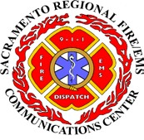

*10230 Systems Parkway, Sacramento, CA 95827-3006*

[*www.srfecc.ca.gov*](http://www.srfecc.ca.gov/)

Cancelation of SRFECC Regular Board Meeting

The following Regular Governing Board Meeting of the Sacramento Regional Fire/EMS Communications Center, held at 10545 Armstrong Ave., Mather, CA 95655, has been canceled:

CANCELED Board Meeting(s):

Tuesday, April 12, 2022

10545 Armstrong Ave, Mather, CA 95655-4102

Posted: April 8, 2022

By: Marissa Shmatovich

Clerk of the Board